**Agenda item 5b. Re-review of abundance indices to be considered for use in candidate MPs (CMPs)**

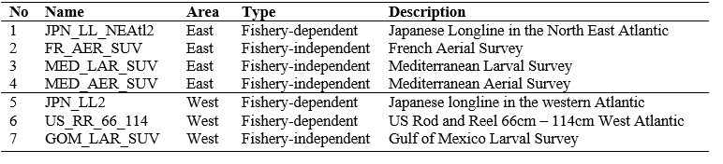

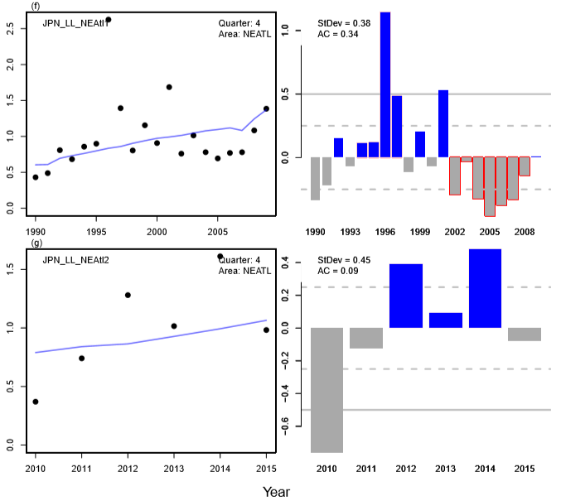**EAST**

1. JNP_LL_NEAtl2

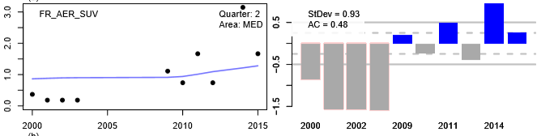

2. FR_AER_SUV

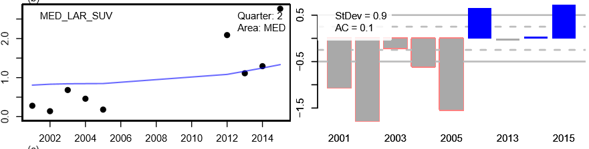

3. MED LAR SUV

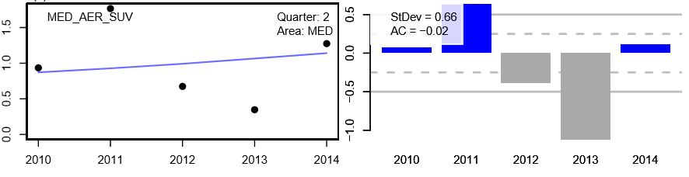

4. MED AER SUV

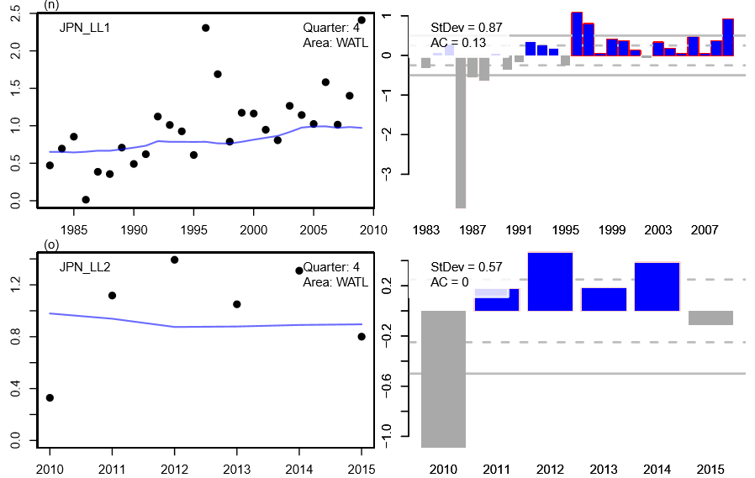**WEST**

5. JPN_LL2

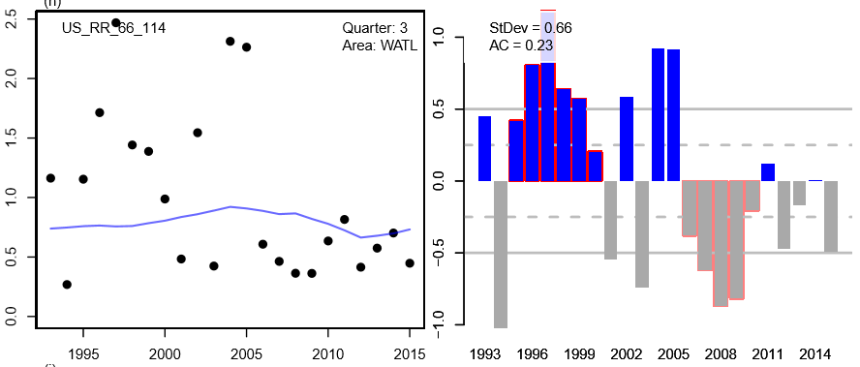

6. US RR 66 114

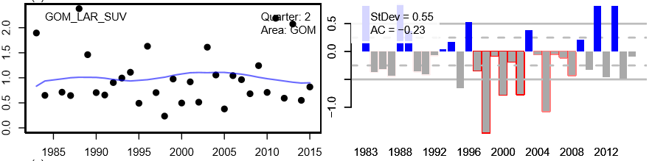

7. GOM_LAR_SUV

**Agenda item 6b. Approval of models to be used to generate future abundance index data**



**Agenda item 6c. Refinement of, and procedures for conditioning robustness trials (with their confirmation)**

## Trial specifications 9.B. Robustness trials

Each of these is a single factor variant on each of two scenarios from the *Reference Set*: [1, A, I] and [2, A, I]

1. Future recruitment change as in 3), but with prob of 0.05 for each of the first 20 years of projection
2. Unrealised overcatches each year of [X] tons in the West and [Y] tons in the East+Med
3. Use of alternative indices [to be specified] in the MP
4. Alternative combinations of fleets in evaluating selectivities for the operating models
5. An undetected increase in catchability for CPUE-based abundance indices of 1% per annum
6. Alternative assignments to stock of origin of historical catches from the South Atlantic
7. Alternative master index

*“Second round” issues*

The following aspects of uncertainty are suggested to be postponed at this time for consideration rather in a “second round”:

1. More than two stocks
2. More than two indices of abundance used as input to a MP
3. Use of CAL data in an MP
4. TACs allocated on a spatially more complex basis than the traditional west and East+Med
5. Changes in technical measures affecting selectivity
6. Changes in stock distributions in the future
7. Future changes in proportional allocation of TACs amongst fleets

Other possibilities

a) non-linearities (hyperstability / hyperdepletion) in the relationship between indices and OM abundance